Unveiling the Enchanting South – Tamil Nadu & Kerala

Day 01 Arrive Chennai – Mahabalipuram
Upon arrival in Chennai, you’ll meet our representative who will assist you at the airport and later, you will transfer to Mahabalipuram and check-in at the hotel (accommodation shall be held from 1400 hrs onwards).

Remainder of the day is at leisure
Overnight in Mahabalipuram

Day 02 Mahabalipuram
Mahabalipuram is a historical retreat set amidst natural beauty. Lying 58 kms South of Chennai, this ancient seaport of the Pallava dynasty invites connoisseurs of art. Its monuments hewn out of solid rock, though ravaged by the sea and wind, still bear testimony to the magnificent heritage of Dravidian architecture. The sculpture here is particularly interesting because it shows scenes of everyday life - women milking buffaloes, pompous city dignitaries and artful looking young girls.

Afterwards, proceed for a city tour of Mahabalipuram.
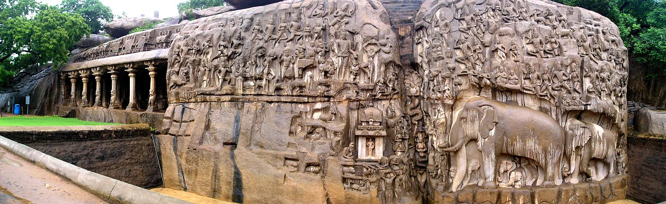

Visit the great Bas-relief of Arjuna's penance - a panel depicting the mythical story of the river Ganges issuing from its source high in the Himalayas and shows animals, deities and other semi divine creatures, fables from the Panchatantra and Arjuna doing a penance to obtain a boon from Shiva.

Next, see The Five Rathas – a UNESCO Heritage and an excellent example of monolithic Indian rock-cut architecture, they are carved out of a single granite rock formation, each one of them named after the heroes of the Mahabharata epic.

Proceed to the glorious Shore Temple – a UNESCO Heritage and one of the oldest in South India, standing on the seashore with its paved forecourts. It represents the final phase of Pallava art built in the late 7th century. The weathered perimeter walls support long lines of bulls and mythical deities that guard the entrances.
Overnight in Mahabalipuram

Day 03 Mahabalipuram – Pondicherry (02 hrs drive)
After breakfast, check-out of the hotel and drive to Pondicherry. Upon arrival check-in at the
hotel.

Pondicherry is a French colonial settlement in India until 1954, is now a Union Territory town bounded by the southeastern Tamil Nadu state. Its French legacy is preserved in its French Quarter, with tree-lined streets, mustard-colored colonial villas and chic boutiques. A seaside promenade runs along the Bay of Bengal and passes several statues, including a 4m-high Gandhi Memorial.

Take a walk around the French town and the White town, seeing the legacy left behind by the French rulers of the city. Start from Baker Street and move towards Alliance Française. Along the streets are colonial-era villas decorated in pastel and ochre shades, with boulevards lined with stunning green trees. On one such street, named Dumas, is Cluny Embroidery Centre, again an old colonial building but with local women who work there now, producing exquisite French-colonial hand embroidered home furnishings. Pick up a souvenir or two from here. End your walk through this beautiful area at Alliance Française. Located inside a pristine white villa, it stares out at the French Quarter on one side and the sea on the other.

Day 04 Pondicherry (02 hrs drive)
After breakfast, visit Auroville founded in 1968, is an experimental township where people of all nationalities live in peace and progressive harmony. Roam around the complex, understand the culture and way of life here.
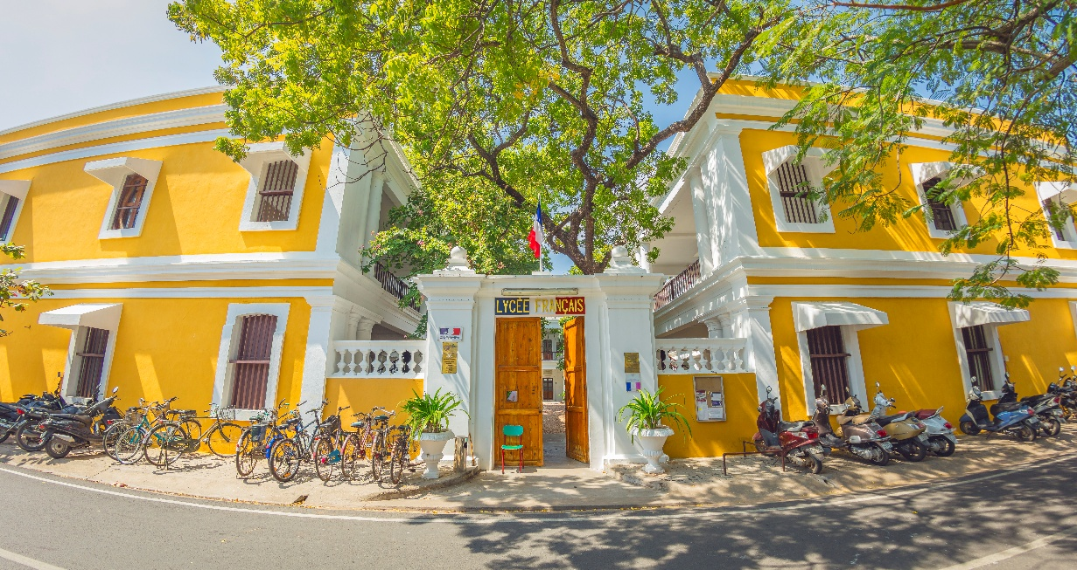

Later, walk through the local markets / beach side.
Overnight in Pondicherry

Day 05 Pondicherry – Chidambaram – Darasuram – Tanjore (05 hrs drive)
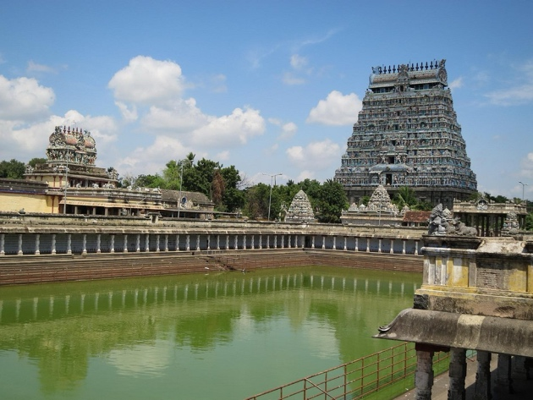
Post breakfast, depart for Tanjore enroute visiting Chidambaram, where we will visit remarkable sacred complex characteristic of Dravidian India: the Nataraja Temple where Shiva is worshipped in the form of the dancing god. Visit Darasuram, a small town whose temple is a superb example of Chola architecture with its columns decorated with miniature sculptures.

Reach Tanjore and check-in at the hotel.
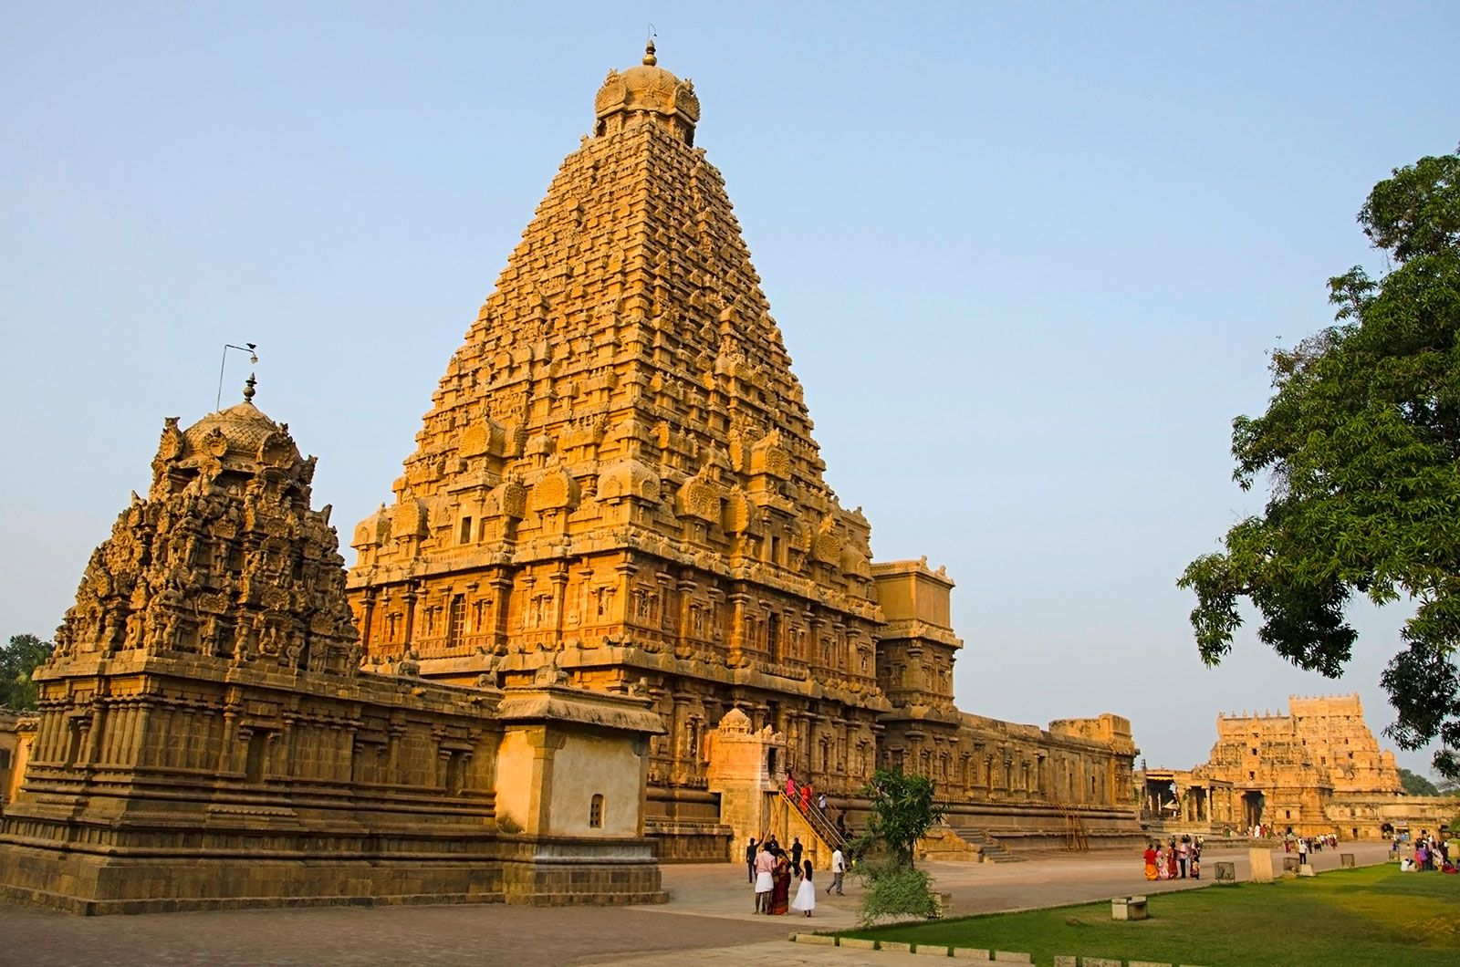
Later, visit the Brihadeeshwara Temple and the Palace, which has a very interesting gallery of ancient bronzes.
Overnight in Tanjore

Day 06 Tanjore – Chettinad (04 hrs drive)
After breakfast, check-out of the hotel and drive to Chettinad. Upon arrival check-in at the hotel.

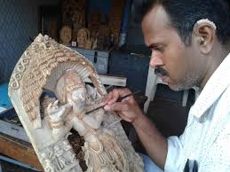
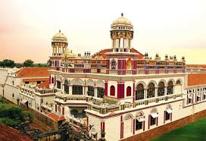
Chettinad region was inhabited by a community of very rich merchants, the Chattiars, who built extraordinary homes in their own style. The craft tradition is still very much alive in the 74 villages that make up this region. Discover this exceptional and unique heritage in India, between forgotten hamlets, little-known sanctuaries, romantic palaces, sacred woods with paths lined with wonderful terracotta horses, village markets and workshops of artisan-artists (wood carving, weaving, or a factory of earthenware tiles renowned throughout India...)

Evening, explore the charming village of Karaikudi and you can visit workshops for wood works, Silver, textiles etc. Also, visit the palace and the museum.
Overnight in Chettinad

Day 07 Chettinad
After breakfast, explore local villages and artisans.
Overnight in Chettinad

Day 08 Chettinad – Madurai (03 hrs drive)
After leisurely breakfast, drive to Madurai and check-in at the hotel. The rest of the day is at leisure to explore this marvel town.

Madurai. Situated on the banks of River Vaigai, this ancient capital of the Pandyan Kings, is a sacred place. In its ancient heyday, Madurai traded with Greece and Rome and was the centre for Tamil poetry and literature. Today, it is symbolized by the iconic Meenakshi temple, visited on morning and evening tours, along with its surrounding bazaars. Other attractions are the noteworthy Tirumala Nayak Palace, and Temple Tank, which is usually the centre for Madurai’s many festivals.
Overnight in Madurai

Day 09 Madurai
After breakfast, visit the Thirumala Nayak Palace constructed in a blend of Dravidian and Islamic styles in 1639 AD. The curved dome, standing without the support of a girder or rafter, is an architectural feat. Pass by the Mariamman Teppakulam - the tank with a mandapam or raised dais in the center.
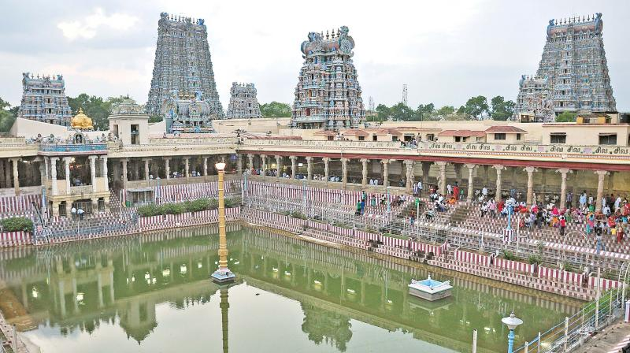

Visit the Meenakshi temple – a superb example of Dravidian architecture and sculpture, the focal point around which the city has developed. Even though the temple has two main sanctums, one dedicated to Shiva and the other to Meenakshi, Goddess Meenakshi is considered the main deity. This could be based on the matrilineal traditions of south India. The splendidly carved temple complex, with its immense gopurams or towering gateways adorned with colourful stucco images of gods, goddesses and animals and tales from Hindu mythology, and its many sculpted and pillared halls, dominates the city skyline.

In the evening, attend the night ceremony at the Meenakshi Temple. This is a ceremony that takes place every evening at 9:00 PM, when the temple bronze of Lord Shiva is carried to the boudoir of his consort, Parvati. The procession is accompanied by religious prayer and temple music.
Overnight in Madurai

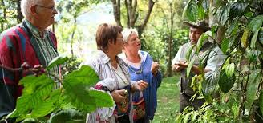
Day 10 Munnar – Periyar (03 hrs drive)
After breakfast, drive to Periyar (also known as Thekkady) - one of the world's most fascinating wildlife reserves. The Periyar wildlife sanctuary in Thekkady is spread across 777 sq km of which 360 sq km is thick ever green forest. Noted for its geomorphology, diversity of wildlife and scenic beauty, the sanctuary was declared a Tiger Reserve in 1978.

Enjoy guided Spice Plantation Tour to the nearby garden where various species of spices and other aromatic plants are cultivated.
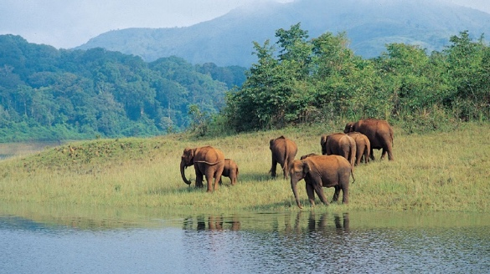
Overnight in Periyar

Day 11 Periyar
After breakfast, enjoy a boat cruise on Lake Periyar in the national park, known for its herds of wild elephants, bison, deer, and spectacular birds.

The afternoon is free.
Overnight in Periyar

Day 12 Periyar – Alleppey – Houseboat
Post breakfast, you travel to the backwaters at Alleppey, “Starting point”, from where you embark houseboat, your floating hotel for the next 24 hours.

Lunch on the houseboat

Once on your houseboats enjoy the lazy countryside.
Watch the life that lives along the canals – the heartbeat of existence of the local peoples. The network is used to transport cargo from the interiors ferry locals between villages, school children run patrols……. Stream past slow boats with single sails made of old sacks stitched together laden with green mounds of coconuts or piles of shells. It is a languid effortlessly unwinding cruise.

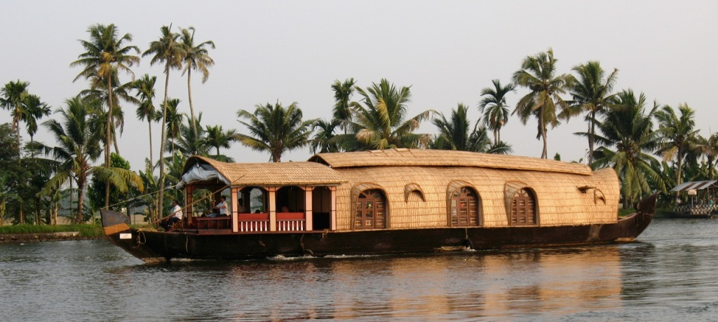

Cruise down the centuries-old backwaters flanked by picture-book towns and ancient trading ports. Palms meeting overhead are a green canopy. Sail through the jade-smooth waters passing quacking squadrons of ducks surrounding oared boats carrying cycles bearded Syrian Christian priests, newsboys and fishwives with an aromatic basket. People fish, swim, wash clothes with the squeaky-clean perfection of Kerala.

Each boat comes with a crew of 4 staff who are your guide, cooks & boatmen. Each houseboat has 2/4 bedrooms, and the houseboats will travel in convoy past the various canals.
Dinner & overnight onboard Houseboat

Day 13 Houseboat – Alleppey – Mararikulam (60 mins drive)
After breakfast, drive to Mararikulam and check-in at the hotel. Relax at the hotel / beach
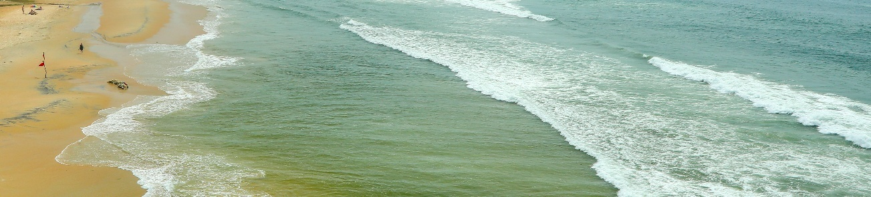
Overnight in Mararikulam

Day 14 Mararikulam
Full day relax at the hotel / beach
Overnight in Mararikulam

Day 15 Mararikulam – Kochi (02 hrs drive)
Morning drive to Kochi. Visit Mattancherry Dutch Palace (closed on Fridays) which was built by the Portuguese in 1555 and renovated by the Dutch in 1663. In the ancient rooms are 17th century murals that relate in vibrant color the story of the epic Ramayana. Visit a Jewish Synagogue (closed on Fridays, Saturdays and Jewish holidays) in Jew Town and Fort Cochin Area - Legend dates Jewish trade with Kerala from the times of King Solomon. Visit St. Francis Church, the oldest European Church in India.

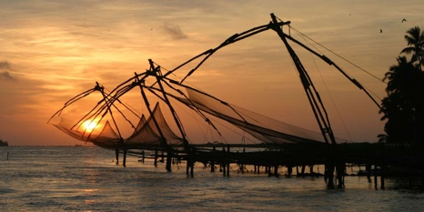
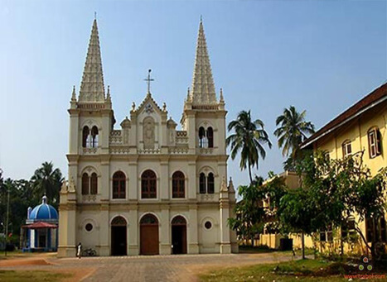
In the evening, visit Fort Cochin area. See the Chinese Fishing Nets, along the tip of Fort Cochin unique to this part of Kerala and living symbols of a centuries-old Chinese influence on this coast.
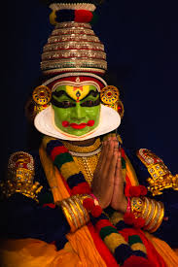

Afterwards, enjoy Kathakali Dance Performance at a local theater, a strenuous dance form once only the bastion of men for the high energy required to perform tells stories from the Mahabharata & Ramayana where Gods are made larger than life the colours clearly differentiate the good from the bad and the size of costume differentiate the Gods from the mere mortals. Facial and hand gestures tell innumerable stories, so it is a good idea to watch the artists put on their make up for a show – an elaborate process as the colours is made from natural mineral & stone – no chemicals for them.
Overnight in Kochi
Day 16 Kochi – Departure
After breakfast, transfer to airport for onward flight.

End of Tour

Unveiling the Enchanting South – Tamil Nadu & Kerala
(Cost / Terms & Conditions)

Based on following hotels:

City | Standard Hotels | Superior Hotels | Deluxe Hotels | Luxury Hotels | Meals
Mahabalipuram | Mamalla Heritage  (Standard Room) | MGM Beach Resort  (Club Room) | Ideal Beach Resort  (Garden View Room) | Radisson Temple Bay (Garden Room) | B
Pondicherry | Les Hibiscus  (Standard Room) | Villa Helena  (Standard Room) | Villa Shanti  (Standard Room) | CGH Palais De Mahe  (Mahe Chambre) | B
Tanjore | Parisutham  (Svatma Room) | GRT Great Trails  (River View Room) | GRT Great Trails  (Garden View River Room) | GRT Great Trails  (Garden View River Room) | B
Chettinad | Chettinadu Mansion  (Deluxe Heritage) | CGH Visalam  (Chettinad Room) | Chidambara Vilas  (Heritage Room) | Saratha Vilas  (Heritage Room) | B
Madurai | J C Residency  (Executive Room) | The Royal Court  (Superior Room) | Heritage Madurai  (Deluxe Club Room) | Taj Pasumalai  (Premium Room) | B
Periyar | Greenwoods  (Superior Room) | Xandari Cardamom County  (Periyar Cottage) | Amritara Shalimar Spice Garden  (Elegant Room) | Spice Village  (Spice Garden Cottage) | B
Backwaters | Deluxe Houseboat | Deluxe Houseboat | Deluxe Houseboat | Luxury Houseboat | B,L,D
Marari | Azure tides  (Cottage) | Abad Turtle Beach  (Beach Cottage) | Xandari Pearl  (Green Pearl Room) | CGH Marari Beach  (Garden Villa) | B
Kochi | Fort House  (Standard Room) | Tea Bungalow  (Heritage Deluxe Room) | Forte Kochi  (Classic Room) | Brunton Boatyard  (Sea Facing Room) | B

*B-Breakfast, L-Lunch, D-Dinner

Prices: (Valid for 01 Oct 2025 – 31 Mar 2026)

Particulars | Prices – Per Person (EUR)
 | Standard Hotels |  | Superior Hotels |  | Deluxe Hotels |  | Luxury Hotels
 | 02-03 Pax | 04-06 Pax | 02-03 Pax | 04-06 Pax | 02-03 Pax | 04-06 Pax | 02-03 Pax | 04-06 Pax
Per Person on Twin  Sharing Basis | 1655.00 | 1465.00 | 1885.00 | 1695.00 | 2265.00 | 2075.00 | 3280.00 | 3090.00
Single Room Supplement | 815.00 | 815.00 | 1045.00 | 1045.00 | 1430.00 | 1430.00 | 2440.00 | 2440.00
Entrances | 60.00 | 60.00 | 60.00 | 60.00 | 60.00 | 60.00 | 60.00 | 60.00
Local English / French Speaking Guide | 210.00 | 105.00 | 210.00 | 105.00 | 210.00 | 105.00 | 210.00 | 105.00
Accompanying French Speaking Guide | 650.00 | 325.00 | 650.00 | 325.00 | 650.00 | 325.00 | 650.00 | 325.00

* Above prices are not valid from 20 Dec 2025 till 10 Jan 2026 (both days included)

The above price includes:
- Accommodation on single / twin rooms at the above-mentioned hotels or similar
- Meals as mentioned above
- Transportation by AC Toyota Crysta Car (02-03 Pax) or AC Tempo Traveler (04-06 Pax) as per the program
- Kathakali Dance Performance at a local theater in Kochi
- Spice Plantation Tour in Periyar
- Common Boat Cruise on Lake Periyar
- GST (Goods & Services Tax) as applicable

The above price does not include:
- Any domestic / international airfare
- Monument entrance fees & services of the guide/s
- Any expenses of a personal nature like tips, laundry, beverages, spa, telephone calls etc.
- Any expenses caused by factors beyond our control like flight cancellation, roadblocks, vehicle malfunction, natural calamities etc
- Any medical or evacuation insurance
- Travel insurance.
- Any other thing not mentioned in the Program / Inclusions

